WOODHALL SCHOOL
www.woodhall.herts.sch.uk
Woodhall Lane, South Oxhey, Watford, Hertfordshire, WD19-6QX.

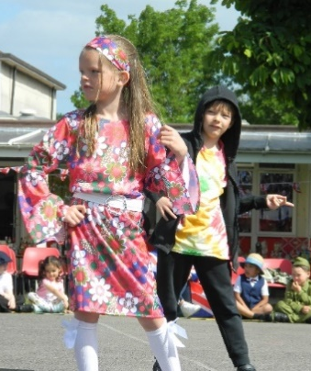
Hello All,
We’ve had such a great term at Woodhall,
So much going on every week.
Oh! The skills we have learned,
The pages we’ve turned!
We thought that we’d give you a peek…

Many days out to great places
(Supporting our knowledge and skills)
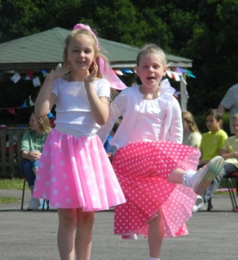
Year 4 and Year 5
Saw the Royal Ballet live-
‘Swan Lake’ in London – such thrills!

Our term has been most thought-provoking;
Refugee Week and Safeguarding themes.
We showed flair and fair play
On our FA Cup day-
(Despite parents who thrashed our school team!)

And music has rung through our hallways
Ukuleles, recorders and more.
Our talent show filled
With such fabulous skills…
Steel drums sang of tropical shores.

We’ve had visitors, clubs and performance,
With ‘wow days’ to make learning fun
School governors too
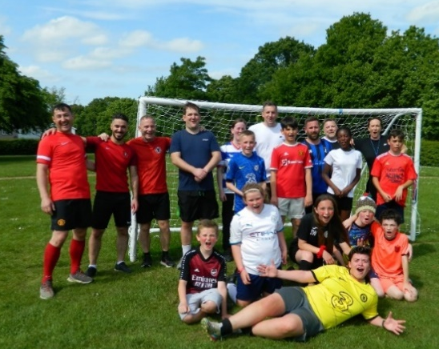
Came to gather our views,
They agreed that we’re second-to-none!

All our families and friends were invited
To see in the Queen’s Jubilee.
Decorations all round;
When our May Queen was crowned
We danced round the Maypole with glee!
Each year group adopted a decade
And danced to a song of their choice.
Early Years took the ‘40s
And Year 6; the Noughties,
We sang ‘Reach for the Stars’ with one voice.

So much in one summer at Woodhall…
Art and maths week, and then some!
We trained new Play Leaders,
Sports’ Buddies, Lunch Readers,
Parliamentary elections to come…

And when we arrived at the last week
Year 6 said goodbye to Woodhall.
We’ll miss them (you bet!)
But we know that they’re set
For the next step of their journey…’big school’!

We’re so proud of ALL of our children
Their resilience, learning, progress.
We’re honoured to be
One big family.
Could you be a part of it? YES!

Come and visit our little school with a big heart, where every day is AMAZING!
We have spaces, and would be very happy to show you around. We are excited to announce that Bluebell Pre-School will soon be opening on our site. Please email Jessica Breakwell (Jessica.breakwell@btinternet.com) or phone her on 07943021909 for further information.

We are really looking forward to the new school year! In the meantime, the children, staff and governors at Woodhall would like to wish everybody in Carpenders Park a very happy and safe summer holiday.

Michelle Lake
Headteacher
head@woodhall.herts.sch.uk
https://www.facebook.com/woodhallprimaryschool

